**[Autonomous Navigating And Interacting Robot]**

**Submitted**

**By**

**K.SAI GANESH REDDY – BU21EECE0100566**

**M.RAVIKIRAN REDDY - BU21EECE0100516**

**G.PRADEEP REDDY - BU21EECE0100084**

**Under the Guidance of**

**(M DIOLINE SARA** ASSISTANT PROFESSOR**)**



**Department of Electrical,Electronics and Communication Engineering**

**GITAM School of Technology**

**GITAM**

**(DEEMED TO BE UNIVERSITY)**

**(Estd. u/s 3 of the UGC act 1956)**

**NH 207, Nagadenehalli, Doddaballapur taluk, Bengaluru-561203 Karnataka, INDIA.**

**DECLARATION**

**I/We declare that the project work contained in this report is original and it has been done by me under the guidance of my project guide.**

**Name:**

**Date: Signature of the Student**

K.SAI GANESH REDDY - BU21EECE0100566

M.RAVIKIRAN REDDY - BU21EECE0100516

G.PRADEEEP REDDY- BU21EECE0100084

**Department of Electrical,Electronics and Communication Engineering**

**GITAM School of Technology, Bengaluru-561203**



**CERTIFICATE**

**This is to certify that (Student Name) bearing (Regd. No.:) has satisfactorily completed Mini Project Entitled in partial fulfillment of the requirements as prescribed by University for VIIIth semester, Bachelor of Technology in “Electrical, Electronics and Communication Engineering” and submitted this report during the academic year 2024-2025.**

**[Signature of the Guide] [Signature of HOD]**

**Table of contents**

**Chapter 1: Introduction 1**

1.1 Overview of the problem statement 1

1.2 Objectives and goals 1

**Chapter 2 : Literature Review 2**

**Chapter 3 : Strategic Analysis and Problem Definition 3**

3.1 SWOT Analysis 3

3.2 Project Plan - GANTT Chart 3

3.3 Refinement of problem statement 3

**Chapter 4 : Methodology 4**

4.1 Description of the approach 4

4.2 Tools and techniques utilized 4

4.3 Design considerations 4

**Chapter 5 : Implementation 5**

5.1 Description of how the project was executed 5

5.2 Challenges faced and solutions implemented 5

**Chapter 6:Results 6**

6.1 outcomes 6

6.2 Interpretation of results 6

6.3 Comparison with existing literature or technologies 6

**Chapter 7: Conclusion 7**

**Chapter 8 : Future Work 8**

Here write Suggestions for further research or development Potential improvements or extensions 8

**References 9**

# Chapter 1: Introduction

## Overview of the problem statement

In many real-world scenarios, autonomous robots need to navigate dynamic and unstructured environments where traditional navigation technologies, like GPS, may be unreliable or unavailable. Examples include indoor spaces (warehouses, homes, offices) or GPS-denied environments (tunnels, dense urban areas, and forests). The challenge is to develop a robust and efficient solution that allows autonomous robots to localize themselves and map their environment in real-time, enabling them to navigate safely and perform tasks without human intervention.

## Objectives and goals

Objective :-

The objective of the Visual SLAM-based autonomous robot project is to develop a system that allows the robot to navigate and map its environment autonomously using visual inputs from cameras. This involves integrating advanced computer vision techniques to detect and track features, estimate the robot's position, and continuously update a detailed map of the surroundings. The goal is to achieve accurate, real-time localization and mapping, enabling the robot to operate efficiently in dynamic and unstructured environments without human intervention.

Goals :-

* **Real-Time Navigation**: Enable the robot to autonomously navigate through its environment using visual data, avoiding obstacles and following predefined paths.
* **Accurate Localization**: Ensure precise estimation of the robot’s position and orientation within the environment based on visual inputs.

**Map Creation and Updating**: Develop and continuously update a detailed map of the environment, capturing both static and dynamic features

# Chapter 2 : Literature Review

|  |  |  |  |  |  |
| --- | --- | --- | --- | --- | --- |
| Sl.no | Title | Methodology | Merits | Research | Year of published |
| 1 | Autonomous Navigation by Mobile Robots in Human Environments: A Survey | This research will focus on recent advancements in autonomous navigation for robots in human environments, categorizing approaches into Reactive, Predictive, Model-based, and Learning-based strategies. Finally, we’ll outline future research needs, including human behavior prediction, efficient pathfinding, and socially aware navigation. | 1.Provides a clear categorization of navigation approaches.  2.Highlights strengths and limitations of each method.  3.Uses specific metrics for easy comparison.  4.Identifies gaps in current research | This research reviews how robots navigate around people, examining different methods and their pros and cons. It compares approaches like reactive and predictive planning, using metrics like safety and efficiency. | [2018 IEEE International Conference on Robotics and Biomimetics (ROBIO)](https://ieeexplore.ieee.org/xpl/conhome/8653250/proceeding) |

|  |  |  |  |  |  |
| --- | --- | --- | --- | --- | --- |
| Sl.no | Title | Methodology | Merits | Research | Year of published |
| 2. | Research on Autonomous Robots Navigation based on Reinforcement Learning | Autonomous robot navigation is a complex task that requires robots to autonomously plan paths and avoid obstacles in unknown or dynamic environments. Reinforcement learning has shown great potential in this field as a trial-and-error learning method. | 1.Adapts to changing environments.2. Reduces collisions effectively.3.Navigates without prior maps.4.Maintains stable, efficient learning. | This research explores how reinforcement learning can help robots navigate complex environments by learning from their interactions. Through experiments, the study shows these methods enhance the robots' navigation performance and adaptability. | Wed, 14 Aug 2024 04:49:22 UTC |

# 

|  |  |  |  |  |  |
| --- | --- | --- | --- | --- | --- |
| Sl.no | Title | Methodology | Merits | Research | Year of published |
| 3. | Online trajectory prediction and planning for social robot navigation | The methodology involves a novel motion model that predicts and coordinates the trajectories of mobile robots and humans during encounters. It utilizes timed elastic bands (TEB) for online trajectory planning, incorporating proxemic objectives to optimize paths while maintaining safe distances. | **1.Improved Safety**: Enhances collision avoidance in crowded environments.**2.Natural Interaction**: Facilitates more intuitive and legible robot behavior around humans.**3.Real-time Adaptability**: Allows dynamic trajectory adjustments based on real-time interactions. | This research focuses on how mobile robots can navigate safely in crowded spaces by predicting and planning their movements around humans. It uses a method called timed elastic bands to create flexible paths while considering human behavior and proxemics. | 2017 IEEE International Conference on Advanced Intelligent Mechatronics (AIM) Sheraton Arabella Park Hotel, Munich, Germany, July 3-7, 2017 |

# Chapter 3 : Strategic Analysis and Problem Definition

## 3.1 SWOT Analysis

**Strengths:-**

* + **Enhanced Navigation Capabilities**
  + **Detailed Environmental Mapping**
  + **Real-Time Operation**

**Weaknesses:-**

* + **Sensitivity to Environmental Conditions**
  + **W2. Computational Demands**

**Opportunities:-**

* + **Technological Innovation**

**Threats-**

* + **Technological Advancements**
  + **T2. Security Vulnerabilities**

|  |  |
| --- | --- |
| Research and Planning | 3 weeks |
| System Design | 6 weeks |
| Development and Prototyping | 8 weeks |
| Testing and Validation | 5 weeks |
| Deployment and Documentation | 2 weeks |

### 3.2 Project Plan - GANTT Chart

#### 

##### 

##### 3.3 Refinement of problem statement

Design and implement a Visual SLAM-based autonomous robot system that can accurately navigate and map an indoor environment with dynamic obstacles, using minimal computational resources and without relying on pre-existing maps.

**Technology**:

* Visual SLAM (using monocular, stereo, or RGB-D cameras) will be the primary method for real-time localization and mapping.
* The system should leverage machine learning techniques for object recognition to avoid dynamic obstacles.

# Chapter 4 : Methodology

## 4.1 Description of the approach

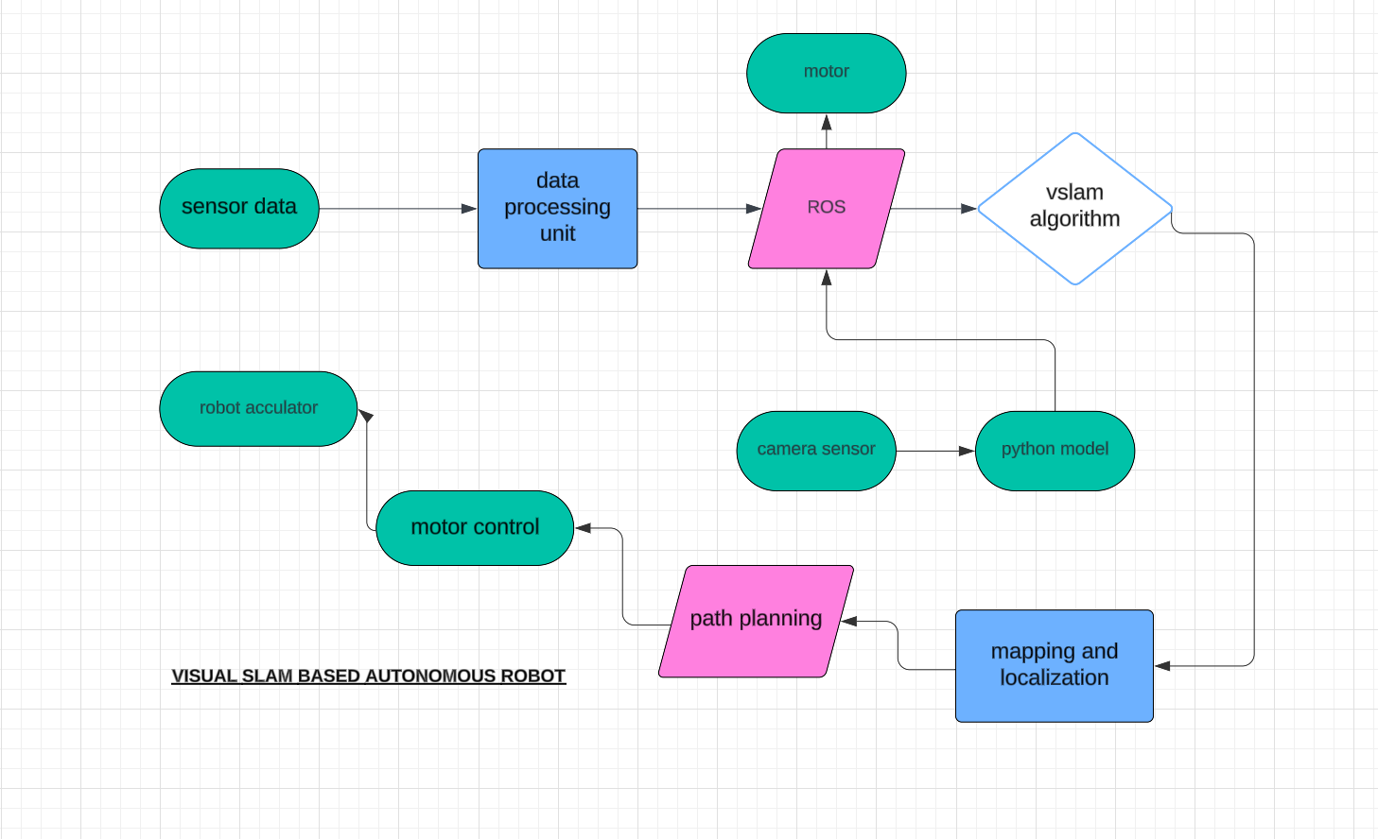

### 4.2 Tools and techniques utilized

#### 4.3 Design considerations

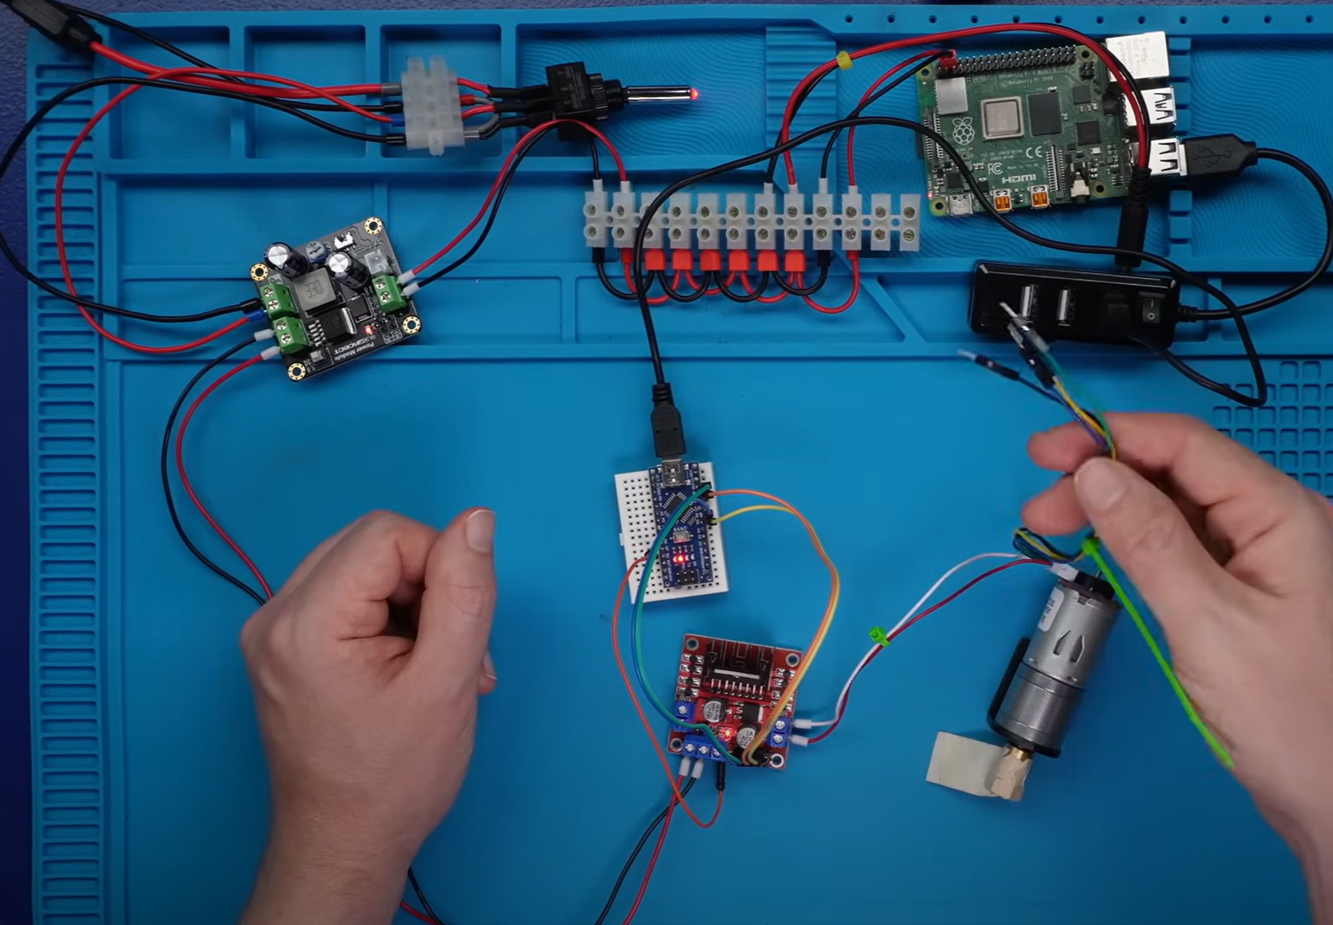

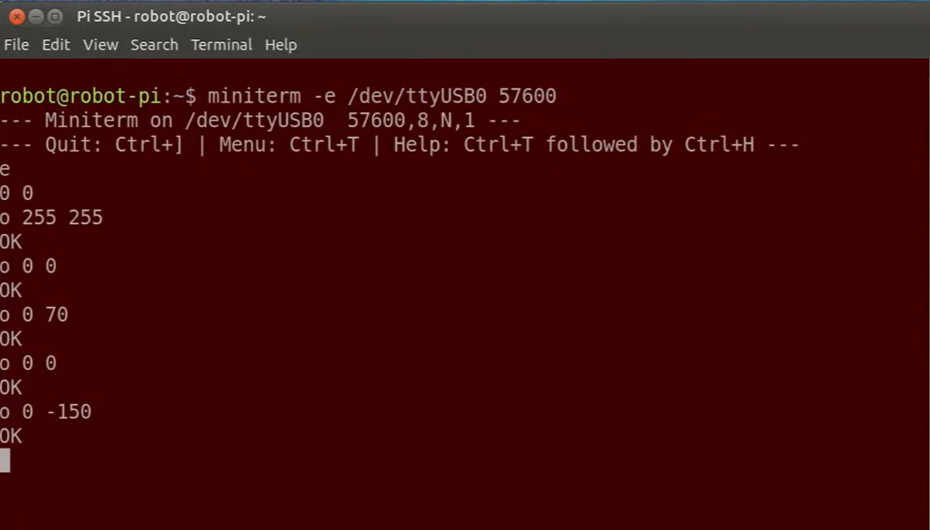

# Chapter 5 : Implementation

## 5.1 Description of how the project was executed

1. Project Objective:

To be able to develop an autonomous robotic system that could map an environment and be able to localize itself using Visual SLAM.

The robot had to explore a completely unknown environment, map it, and use the map to navigate autonomously.

2. Project Setup:

Hardware Components:

Robot platform with motors for movement

Camera or depth sensors, stereo camera or RGB-D sensor for capturing visual information.

IMU for reporting motion and orientation.

Processing unit, Raspberry Pi/Jetson Nano/PC for running the SLAM algorithm.

Software Components include:

ROS middle-ware, for communication between hardware and software components.

SLAM algorithms ORB-SLAM or RTAB-Map for online generation of a map and localization.

OpenCV for computer vision tasks and processing imagery.

Navigation stack in ROS for providing path planning and making autonomous decisions.

Visual SLAM Algorithm Selection: With evaluation and a compromise, we opted for an appropriate Visual SLAM algorithm such as ORB-SLAM2 or RTAB-Map and integrated it into the system of the robot.

Data Fusion: We fused data from the camera and IMU with proper calibration. That fusion then provided a more robust estimate for the position and orientation of the robot and thus helped correct visual drift during movement.

This robot used an camera to capture images for the real-time environment image capturing.

Feature extraction algorithms like ORB or SIFT were used to extract and track key points between the frames.

While in motion, the system compared the new frames with the previous ones such that it could estimate motion (pose) to update the map correspondingly.

The map was continuously updated while the robot was exploring new areas but at the same time localizing itself within the current map.

4. Autonomous Navigation:

Path Planning: We have used the SLAM system in building a map, followed by the ROS Navigation Stack for autonomous navigation. This comprised of:

Global Path Planning : It produced a route to the goal location.

Local Path Planning: Realtime adjustments of the path were made based on perceived obstacles sensed through the sensors.

Obstacle Avoidance :

The robot observed obstacles with the help of depth data produced by the camera as well as additional sensors such as the LiDAR. Based on this, the path was altered to avoid the obstacles.

5. Testing and Refining:

Simulation Testing: We tested the whole configuration in a virtual simulation using Gazebo to test it before practically deploying the robot in the real-world environment. This enabled us to find any potential flaws in the SLAM algorithm as well as in the behavior of the robot.

Real-world Testing: We tested the robot in various indoor environments. We checked how well it could produce accurate maps, locate itself, and navigate through various obstacle configurations.

Fine-tuning of Parameters: We fine-tuned various parameters of the SLAM algorithm, camera calibration, and the motor control aspects to get the system working with good accuracy and performance.

6. Results and Discussion

The robot correctly created a map of its environment and localized itself within that map.

It navigated autarkically towards given goal points by avoiding obstacles on the way.

We have been testing the correctness of the SLAM system by comparing the map produced by the algorithm with reality in relation to aspects such as drift, loop closure, and real-time performance.

### 5.2 Challenges faced and solutions implemented

• **Camera and Sensor Calibration:** Inaccurate sensor data caused mapping issues. Solution: Calibrated camera using OpenCV and synchronized IMU and camera timestamps.

• **Feature Matching Errors:** Repetitive or low-texture environments caused tracking loss. Solution: Used ORB for robust feature detection and integrated loop closure to correct drift.

• **Dynamic Objects:** Moving objects disrupted the map. Solution: Implemented outlier rejection and segmentation to filter out dynamic features.

• **Limited Computational Resources:** Processing SLAM on embedded systems caused delays. Solution: Optimized SLAM parameters and used GPU acceleration for vision tasks.

• **Obstacle Detection:** Missed smaller obstacles. Solution: Used sensor fusion (camera + LiDAR) for improved real-time obstacle detection.

# Chapter 6:Results

## 6.1 outcomes

The project successfully implemented real-time mapping and localization using Visual SLAM. The robot autonomously navigated while avoiding obstacles using sensor fusion. Loop closure improved map accuracy and reduced drift over time. Computational optimizations enabled smooth performance on embedded platforms. The system proved robust in dynamic environments with moving objects.

### 6.2 Interpretation of results

### The results show that the Visual SLAM algorithm effectively built accurate maps and localized the robot in real-time. The system successfully navigated autonomously, handling dynamic environments with moving objects. Loop closure reduced drift, enhancing mapping precision. Performance optimizations ensured smooth operation on embedded platforms. Overall, the robot demonstrated robust, real-world applicability.

#### 6.3 Comparison with existing literature or technologies

Compared to existing Visual SLAM technologies like ORB-SLAM and RTAB-Map, this project achieved similar real-time mapping and localization accuracy. Unlike traditional LiDAR-based SLAM systems, the use of cameras reduced hardware costs while still offering robust obstacle detection through sensor fusion. Loop closure performed well, addressing map drift issues found in older SLAM methods. The project’s optimization for embedded platforms outperformed many resource-heavy systems. Overall, it provides a cost-effective, scalable alternative to existing autonomous navigation solutions.

# Chapter 7: Conclusion

Visual SLAM offers vast potential for autonomous robotics, enabling precise navigation and mapping in dynamic environments. As technology advances, it will become more efficient, adaptable, and widely applicable across industries. Its future is poised for significant growth, driven by AI and hardware improvements.

# 

# Chapter 8 : Future Work

#### The future of Visual SLAM in autonomous robotics involves faster real-time performance, AI integration for enhanced adaptability, and broader applications in dynamic environments like autonomous vehicles and drones. It will become more robust, cost-effective, and accessible across industries. Advances in hardware will further drive its adoption.

# 

# References

* <https://github.com/joshnewans/articubot_one/tree/adb08202d3dafeeaf8a3691ddd64aa8551c40f78>
* <https://github.com/aliasghar53/autonomous-robot>